***CASE STUDY: Car rental***

Car rental companies own a number of cars and a number of sites where cars are parked when not in use. Customers rent cars for a period of time (having made a reservation, or not) and return them.

We focus on company CARS.

The current process (AS IS), is as follows.

A customer may reserve a car, using the company web site, or the call center (this step is optional).

A customer steps into the office close to the rental car parking site and completes the first step of the *check out*. The contract for the rental is defined (period of rental, name of driver, related ID document and driving license, insurances, damage deposit, partial and total fees, credit card), signed by both parties, and the payment for the rental is completed (payment has two parts, rental and damage deposit – the latter is normally returned at the end of the rental). Further, a specific car (identified by its tag) is assigned to the rental.

Then the customer walks to the car parking site. Here the second part of the check out happens.

An employee checks with the customer the car and lists all visible damages on the car in an annex to the contract. Also this annex is signed by both parties. Then the employee hands the car to the customer (this of course includes the keys) and the rental starts.

The final step is *check in*. The customer drives the car to parking site. An employee receives the car and the keys, checks with the customer for new damages. If there are damages another process starts (we leave this process out of this analysis). At this point the rental ends. The company issues an invoice and possibly returns the damage deposit to the customer.

TO BE process.

The idea is to improve the process by introducing the same innovations used by car sharing companies.

A customer has first to define an account with CARS. In this step the customer uploads his documents (ID, driving license) and a credit card. If all is right CARS approves and the customer can later rent cars. This step can be performed on a PC or smart phone. In any case the customer has to install the CARS app on her smartphone.

When a registered customer wants to rent a car she has to do a reservation (via app or PC).

Check out works as follows. The customer walks directly to the rental car parking, via the app she signals that she wants to start the rental. The app answers with position and tag of the assigned car.

When the customer is close to the car she asks, via the app, to open the car. The system opens the car (the car needs to be modified via a device connected to the cellular network and capable of controlling some car functions, like door open/close). The keys are inside the car. The customer starts the car, and the rental.

The check in is similar. The customer parks the car in the rental car parking, stops the car, exits, and asks the app to close the car. At this point the rental is over.

Invoicing and payments proceed through the credit card.

Damage deposits and possibly damage reimboursements are avoided, introducing by default an insurance to cover all.

*LAB*

*AS IS*

1 define an organization chart for the company (MS word and powerpoint have tools to draw org charts) (use taxonomies such as Anthony’s model as an inspiration). What kind of structure is it (functional, divisional, ..)?

2 using the LRC and the list of processes of the company, allocate processes to organizational units

TO BE

1 define a new organization chart for the TO BE situation. Has the structure changed?

2 Update LRC if needed

Assumptions: National company (ex Sicily By car – 50 offices, 250 employees, probably 50 in central office, Italy only). Doing short term rental only

(other options: short term rental + long term rental, truck rental + car rental, multinational company with offices everywhere worldwide)

Contents

A -- AS IS 4

1 Organizational model 4

2 Process List 6

3 LRC 6

B – TO BE 6

1 Organizational model 6

2 Process List 7

3 LRC 7

# A -- AS IS

## 1 Organizational model

In yellow the parts as described in the text above. Other parts are assumed considering a large rental company (at least active at country level, with many local agencies)

Besides the rental company (where is our focus), customer and payment circuits are listed since they interact with rental company.

LRC

Car rental company

Accounting (record expenses, record revenues, compute balance sheet, produce tax report)

Finance (find resources, interact with banks)

Human resources (search and hire employees, manage careers, compute salaries)

IT area (manage web site and all IT services, manages call centers - technical part)

Legal department (write customer contracts, manage litigation, provide legal support)

Sales and marketing

Reservation office (manage reservations,

Customer assistance (manage accidents, complaints, defects)

Car management (“manufacturing”) (buy and resell cars)

Local agency (repeated many times, in each city, airport, railway station..)

(geo structure)

Office

Parking site (final part of checkin checkout, (cleaning, small repairs)

Customer

|  |  |  |  |  |  |  |  |  |  |  |  |
| --- | --- | --- | --- | --- | --- | --- | --- | --- | --- | --- | --- |
| Process Unit | SM | SM reservation office | SM customer assistance | Accounting finance legal | IT area | Car management | Car management local agency | CM local agency office | CM local agency parking lot office | Payment circuit | Customer |
| Recor d expense, record revenues |  |  |  | P |  |  |  |  |  | C |  |
| Compute balance sheet |  |  |  | P |  |  |  |  |  | C |  |
| Produce tax report |  |  |  | P |  |  |  |  |  |  |  |
| Create and modify a resrvation |  |  |  |  |  | C |  |  |  |  | P |

Payment circuit (credit card , bank circuit)

(yellow = specific to the part actually described in case study. Non yellow, assumptions about part of CARS not described in case study)

As a reference, below are two org charts of real car rental companies

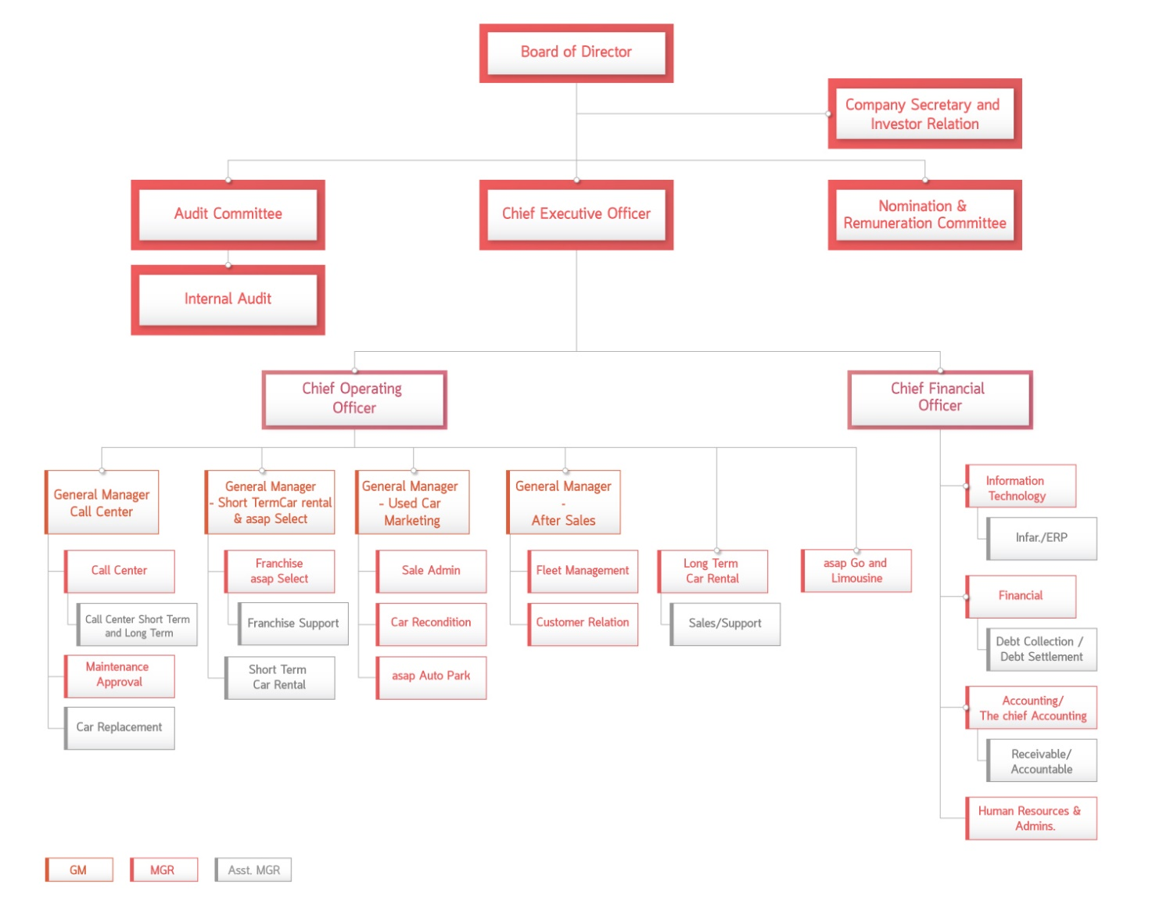

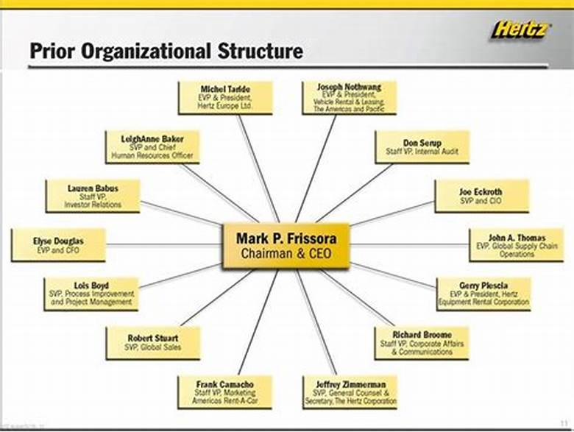

## 2 Process List

List here ALL processes needed by the company

## 3 LRC

Using the linear responsibility chart define, for each process, the OU that is process owner

|  |  |  |  |
| --- | --- | --- | --- |
| Process / Org Unit |  |  |  |
|  | P or C |  |  |
|  |  |  |  |

P = participant (process owner and main player)

C = client (involved marginally in the process)

# B – TO BE

## 1 Organizational model

Car rental company

Accounting

Finance

Human resources

IT area (manage web site and all IT services)

Legal department

Sales and marketing (will implement reservations)

Reservation office

Customer assistance (accidents, ..)

Car management (“manufacturing”)

**Car remote control (ADDED)**

Local agency (repeated many times, in each city, airport, railway station..)

(geo structure)

**~~Office (CANCELED)~~**

Parking site

Maintenance (cleaning, small repairs) (full maintenance is outsourced to external

workshops)

Purchase office (for cars)

Customer

Payment circuit (credit card , bank circuit)

(yellow = specific to the part actually described in case study. Non yellow, assumptions about part of CARS not described in case study)

In the new organization the office part of the local agency is canceled, since damage check and car key delivery are also avoided. Car damage is managed through insurance (see above), keys are not used anymore, the cars are open/closed via remote control. As a consequence the related infrastructure has to be put in place (Car remote control OU). Car remote control works for all local agencies.

Since the organization structure changes, besides process and technology, this is a third order change

## 2 Process List

List only new or canceled or modified processes

## 3 LRC

List only changes to LRC